Part of Speech Tagging
Part of Speech Tagging (POS) is the process of assigning a part of speech to a word. By doing so, you will learn the following:

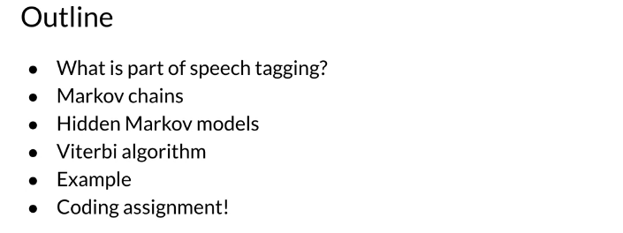

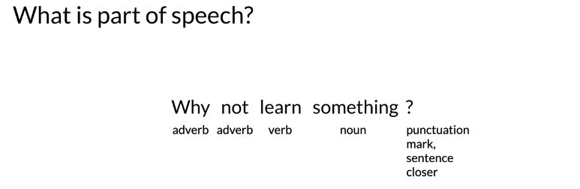

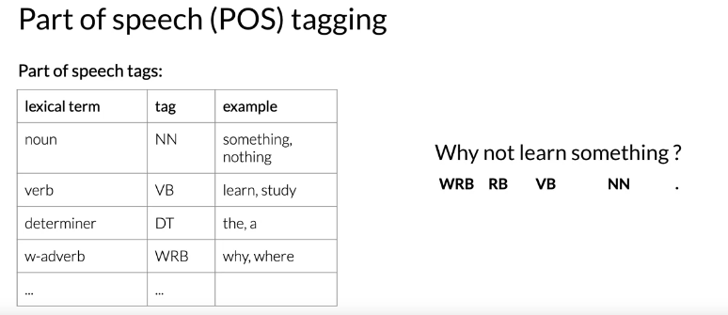

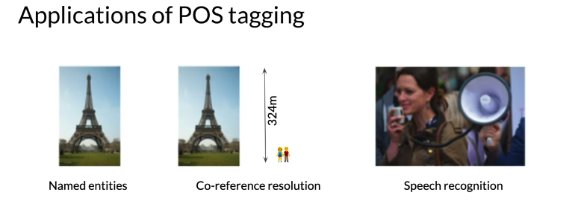

Markov Chains
You can use Markov chains to identify the probability of the next word. For example below, you can see that the most likely word after a verb is a noun.



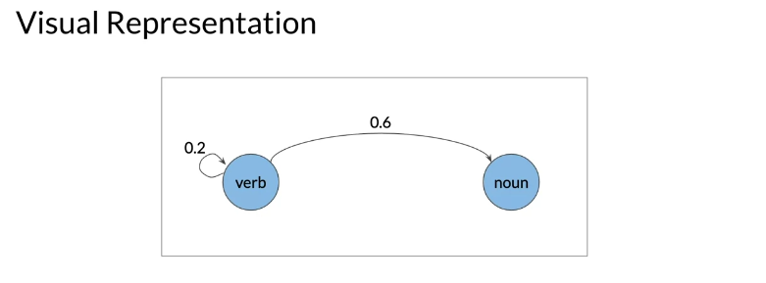

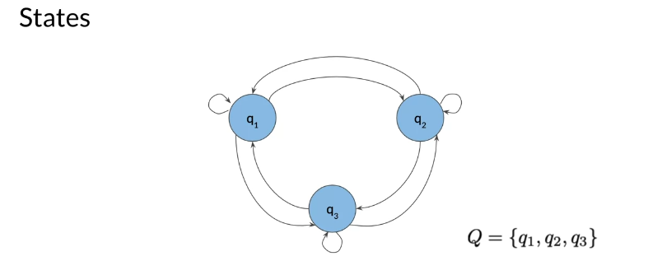

Markov Chains and POS Tags

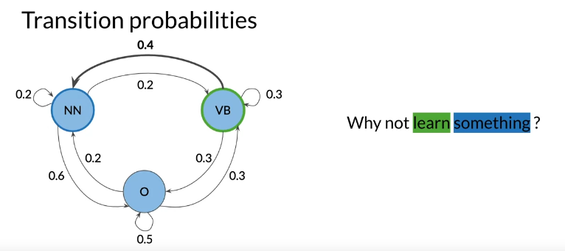

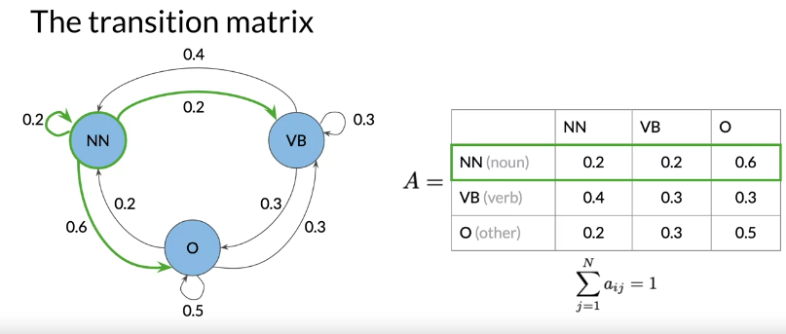

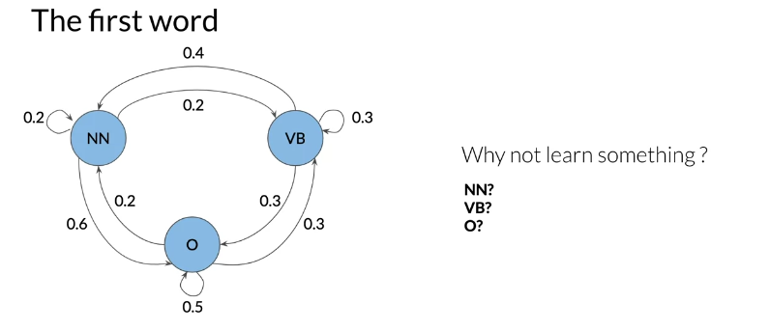

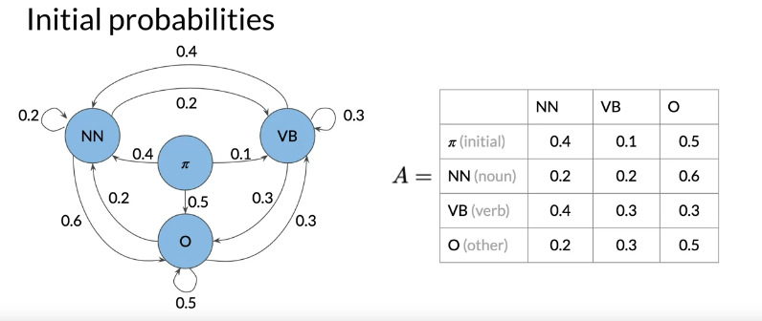

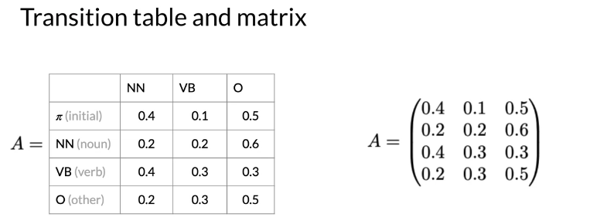

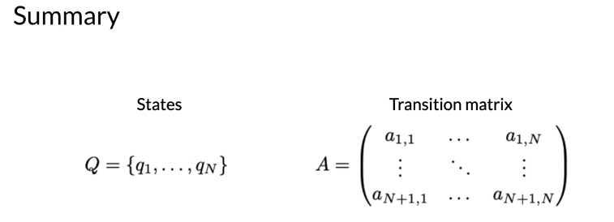

Hidden Markov Models
an example with a simple markov model. The transition probabilities allowed you to identify the transition probability from one POS to another. We will now explore hidden markov models. In hidden markov models you make use of emission probabilities that give you the probability to go from one state (POS tag) to a specific word.

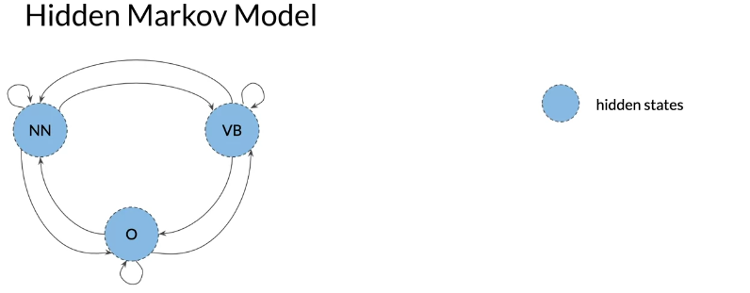
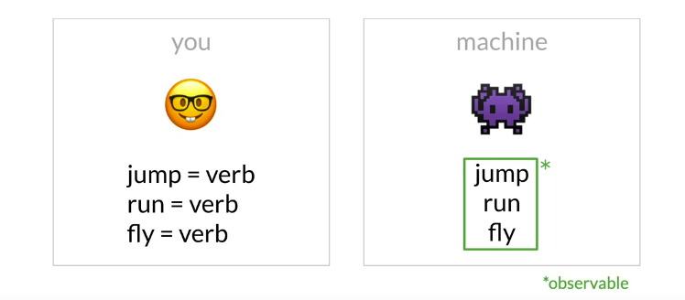

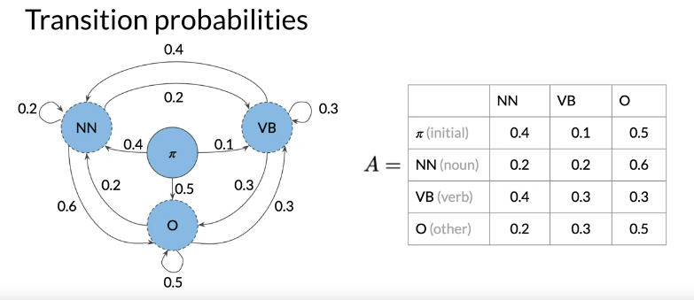

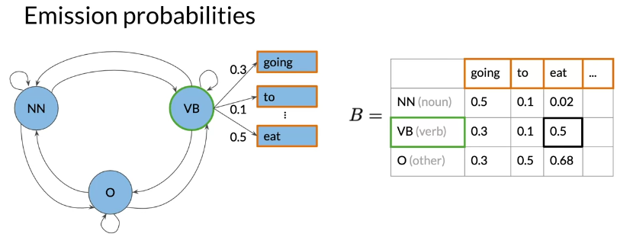

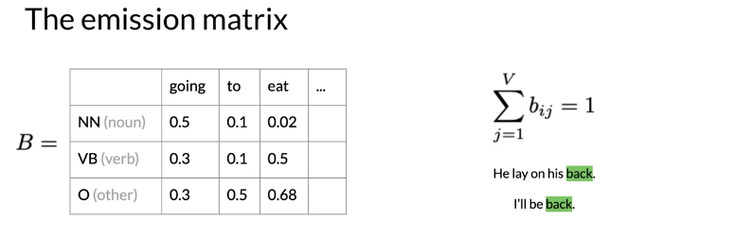

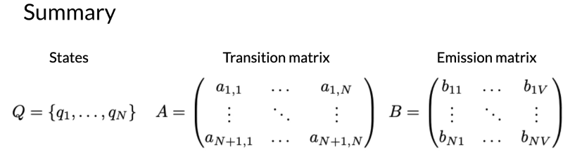

Calculating Probabilities

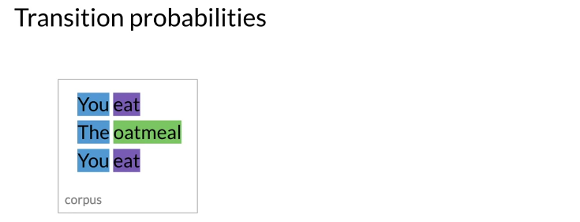

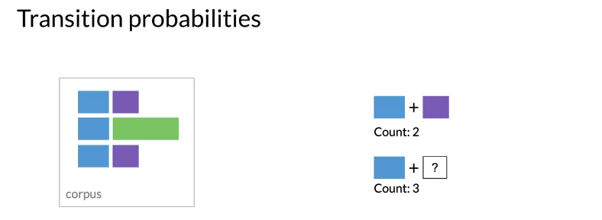

The number of times that blue is followed by purple is 2 out of 3.

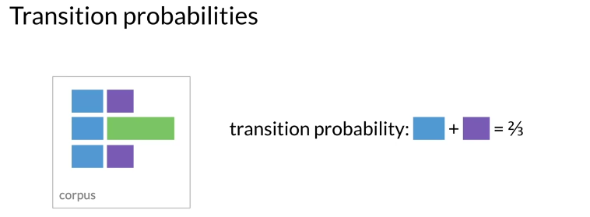

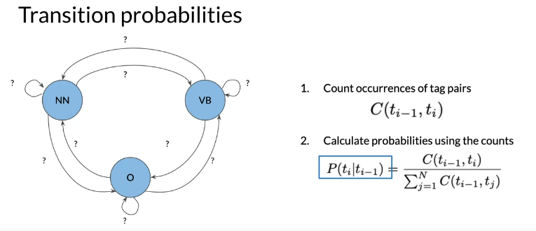

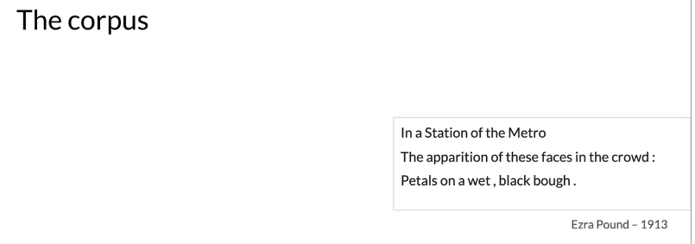

Populating the Transition Matrix

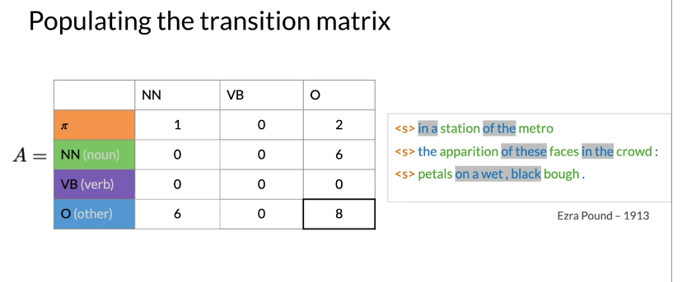

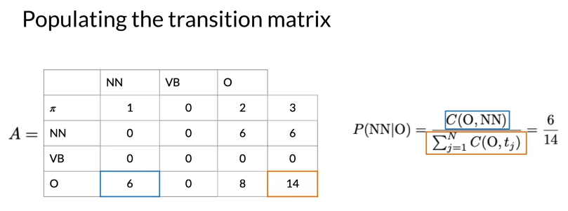

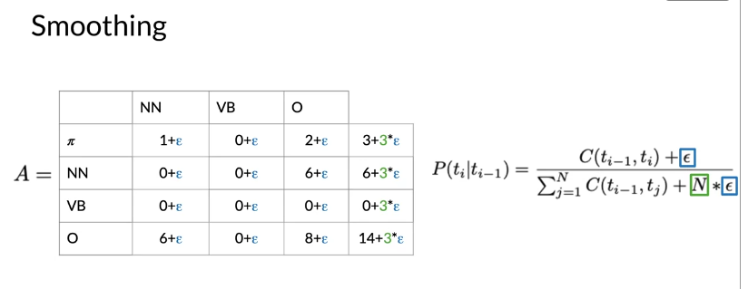

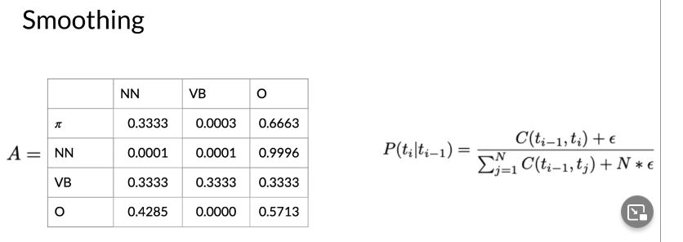

Populating the Emission Matrix

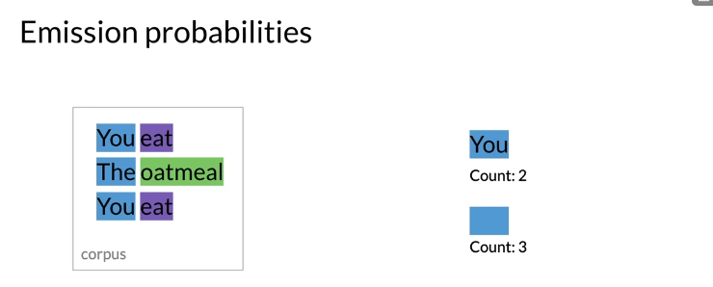

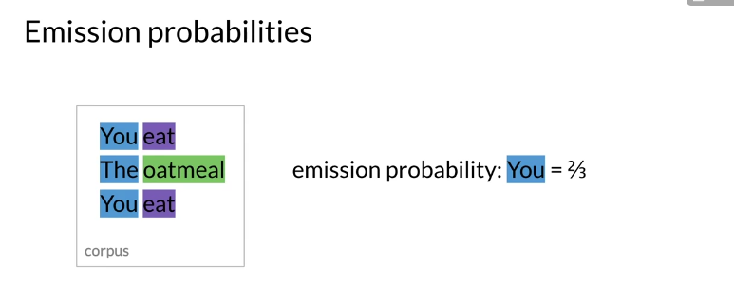

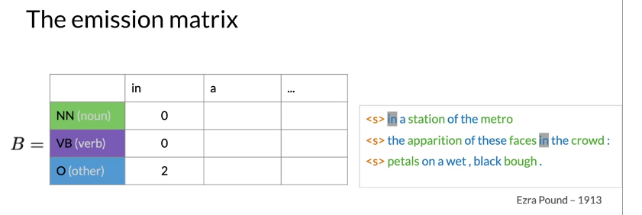

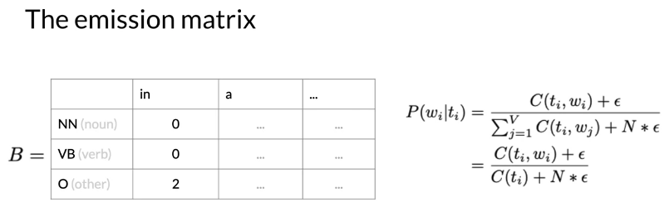

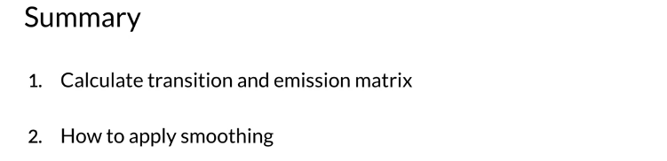

The Viterbi Algorithm


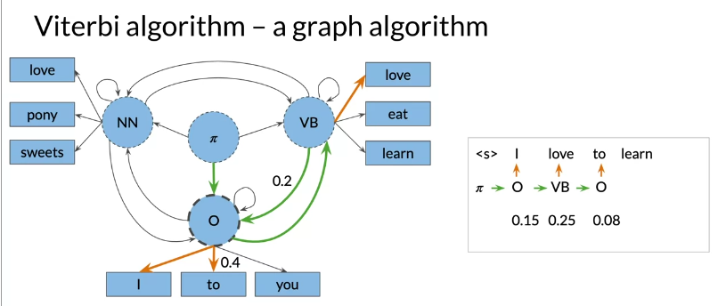

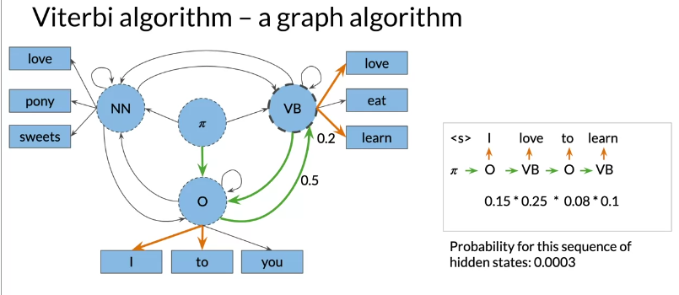

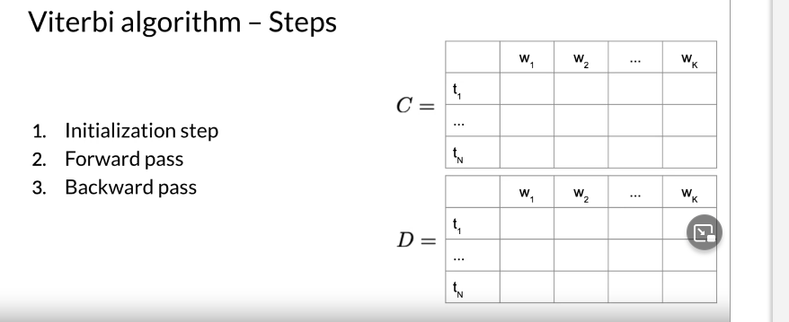

Viterbi: Initialization
You will now populate a matrix C of dimension (num_tags, num_words). This matrix will have the probabilities that will tell you what part of speech each word belongs to.

Now to populate the first column, you just multiply the initial π distribution, for each tag, times bi,cindex(w1​)​. Where the i, corresponds to the tag of the initial distribution and the cindex(w1​), is the index of word 1 in the emission matrix. And that's it, you are done with populating the first column of your new C matrix. You will now need to keep track what part of speech you are coming from. Hence we introduce a matrix D, which allows you to store the labels that represent the different states you are going through when finding the most likely sequence of POS tags for the given sequence of words w1​,…,wK​. At first you set the first column to 0, because you are not coming from any POS tag.

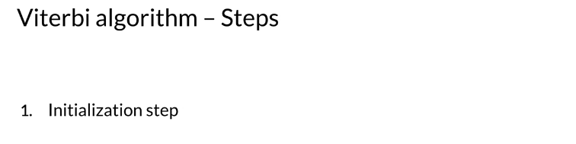

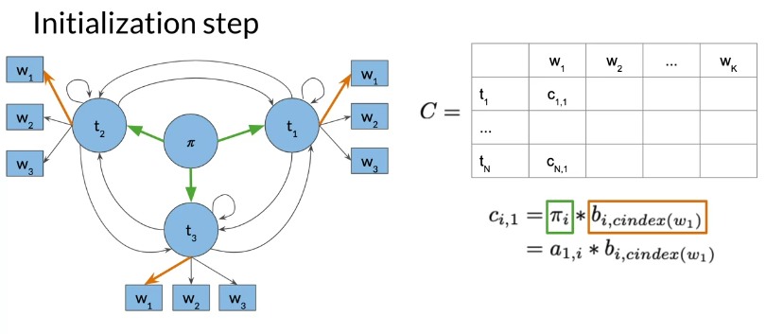

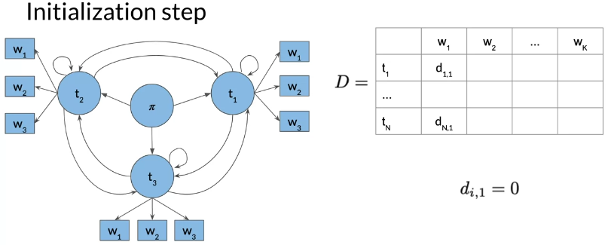

Viterbi: Forward Pass

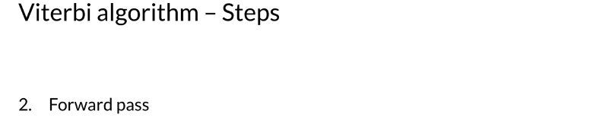
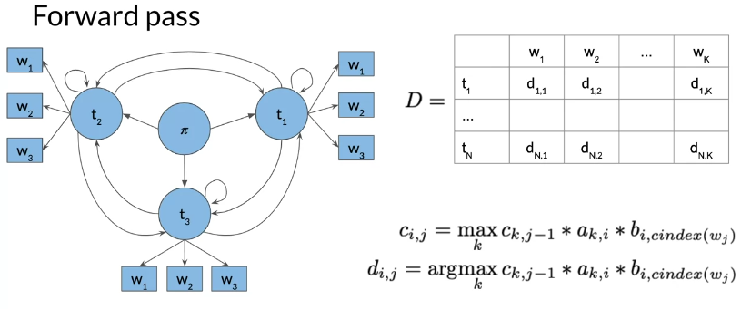
So to populate a cell (i.e. 1,2) in the image above, you have to take the max of [kth cells in the previous column, times the corresponding transition probability of the kth POS to the first POS times the emission probability of the first POS and the current word you are looking at]. You do that for all the cells. Take a paper and a pencil, and make sure you understand how it is done.
The general rule is

Now to populate the D matrix, you will keep track of the argmax of where you came from as follows:
Note that the only difference between cij​ and dij​, is that in the former you compute the probability and in the latter you keep track of the index of the row where that probability came from. So you keep track of which k was used to get that max probability.

Viterbi: Backward Pass

